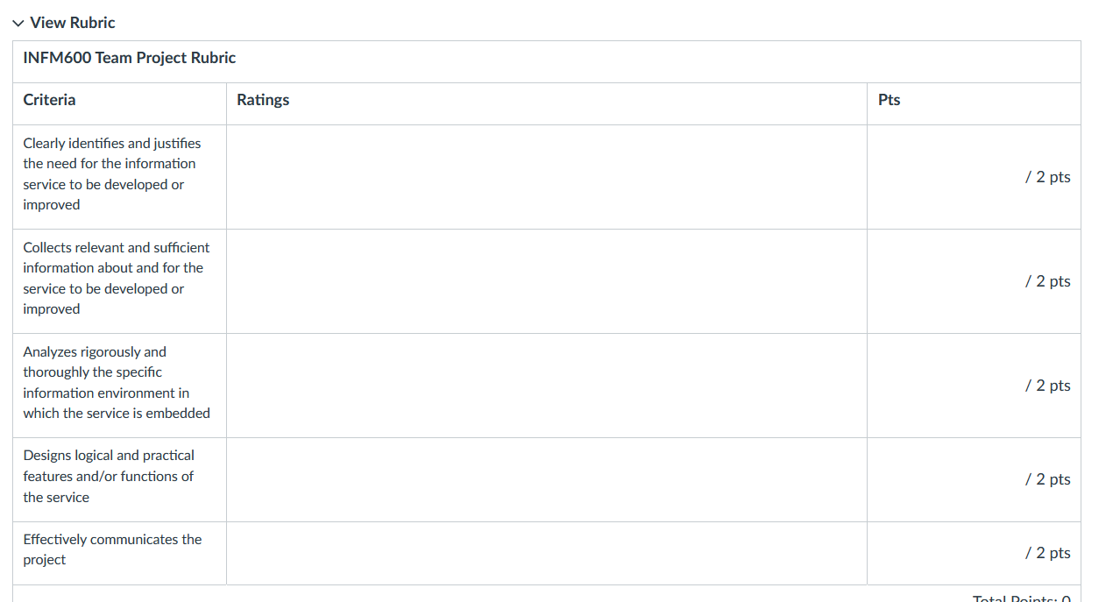

**Comments from Wang:**

Thank you for revising your proposal so quickly! The proposal sounds good. The crowdsourcing feature (user ratings of obstruction/delay) seems cool. However, please think it though – why would the users want to participate? Also, how do other transit apps (for DMV area) collect and analyze the real-time data? Some people may not like the ads, so it might be useful to have a subscription-based (premium) version. Anyway, please go ahead and implement your ideas as proposed. Good luck!

**What is the service?**

The service is an enhanced version of the existing DC Metro Train Status information system, designed to provide accurate, real-time updates about train and bus locations, delays, and disruptions. The service will include new features such as detailed delay notifications, improved real-time data accuracy, crowd-sourced reporting, and better user accessibility. It aims to improve the transit experience for commuters and tourists, promoting the use of public transportation in the Washington, DC area.

**What information is needed?**

Real-Time Transit Data

* Train and bus locations, arrival times, directions, and occupancy levels.

Delay and Disruption Information

* Reasons for delays (e.g., maintenance, weather, technical issues).
* Expected duration of disruptions.

User Feedback

* Reports from users about obstructions, delays, or other transit issues.
* Ratings for crowd-sourced reports to prioritize actionable data.

Environmental Factors

* Traffic conditions and weather reports for predictive analytics.

Accessibility Information

* Multilingual support and hotline details for customer support.

**How information is collected, processed, analyzed, and stored?**

Collection

* Real-Time Data: GPS systems on trains and buses feed location and timing information to a centralized system.
* Delay Data: Metro system backend infrastructure provides updates on operational bottlenecks.
* User Feedback: Crowdsourced inputs from the app's reporting feature are gathered and prioritized.
* Environmental Data: Traffic and weather APIs provide contextual information.

Processing

* Data is cleaned, synchronized, and validated for accuracy using cloud-based infrastructure and algorithms.
* Predictive models analyze environmental data to forecast delays or disruptions.

Analysis

* Machine learning processes real-time data to predict arrival times and recommend optimal routes.
* User feedback is aggregated and verified to identify high-priority issues.

Storage

* Data is securely stored in cloud-based databases for scalability and accessibility.
* Historical data is archived for trend analysis and service optimization.

**The expected utilities and/or impacts of the service?**

Utilities

* Provides commuters with precise, real-time updates on train and bus services.
* Enhances transparency with detailed reasons for delays and disruptions.
* Encourages community engagement through crowd-sourced feedback mechanisms.

Impacts

* Improved Transit Reliability: Reduces commuter frustrations and delays, improving public perception of the transit system.
* Increased Public Transit Usage: Encourages more commuters and tourists to rely on public transit, reducing road congestion.
* Environmental Benefits: Promotes eco-friendly transportation options, contributing to reduced carbon emissions.
* Economic Boost: Supports tourism and local businesses by ensuring reliable transportation for visitors.

**Each presentation should include a unifying vision for the service?**

Our vision is to create a reliable, user-friendly, and transparent transit information system for the DC Metro that leverages modern technology to enhance the commuter experience. By addressing existing gaps in real-time data accuracy, communication, and accessibility, the service aims to improve public trust, boost transit adoption, and contribute to a greener, less congested urban environment.

**How is the service embedded in the environment where it is used?**

The service integrates seamlessly into the existing Washington, DC, public transit ecosystem, serving daily commuters and tourists. It connects multiple touchpoints within the environment:

* DC Metro Stations: Real-time updates and alerts are displayed on station monitors.
* Onboard Vehicles: Embedded systems provide route updates and occupancy information.
* Mobile App: Provides personalized transit updates, route suggestions, and service alerts for individual users.
* Tourism and Local Economy: Facilitates more effortless movement for tourists, indirectly benefiting local businesses and attractions.
* The service aligns with DC's goals for sustainable urban mobility by improving transit reliability and user satisfaction.

**The features and functions of the service (data, process, interface, etc.).**

1. Data

* Input Data Sources:
  + Real-time GPS data from trains and buses.
  + Backend operational data for scheduling and delays.
  + User-generated reports (crowdsourced feedback).
  + Environmental data such as weather and traffic conditions.
* Output Data:
  + Accurate arrival times, delay reasons, route suggestions, and real-time alerts.

2. Processes

* Data Collection: Aggregated from GPS devices, operational systems, user reports, and external APIs.
* Data Processing:
  + AI-driven analytics refine and validate the data.
  + Predictive models forecast delays and recommend alternative routes.
* Data Analysis:
  + Insights into commuter behavior and transit patterns for continuous system improvement.
* Data Storage: Secure cloud-based systems ensure scalability and reliability.

3. Interface

* Mobile App Features:
  + Personalized alerts for delays and disruptions.
  + Route optimization suggestions based on real-time conditions.
  + One-tap access to hotline and FAQs for customer support.
* Crowd-Sourced Reporting:
  + Users can report obstructions or delays and upvote reports for prioritization.
* Embedded Station Displays:
  + Real-time train and bus status updates at metro stations.
* User Accessibility:
  + Free app, multilingual support, and features designed for commuters and tourists alike.

4. Environment

* The service integrates seamlessly into the existing Washington, DC, public transit ecosystem, serving daily commuters and tourists. It connects multiple touchpoints within the environment.
* Real-time updates and alerts are displayed on station monitors.
* Embedded systems provide route updates and occupancy information.
* Provides personalized transit updates, route suggestions, and service alerts for individual users.
* Facilitates more effortless movement for tourists, indirectly benefiting local businesses and attractions.

**References**

<https://www.wmata.com/>

<https://link.springer.com/article/10.1140/epjst/e2012-01703-3>

<https://www.locationaware.usf.edu/wp-content/uploads/2010/02/The-Many-Uses-of-GTFS-Data-%E2%80%93-ITS-America-submission-abbreviated.pdf>

<https://www.apta.com/wp-content/uploads/Resources/resources/reportsandpublications/Documents/greenhouse_brochure.pdf>

<https://apta.com/>